**Case 3**

Place-Plus, a real estate development firm, is considering several alternative development projects. These include building and leasing an office park, purchasing a parcel of land and building an office building to rent, buying and leasing a warehouse, building a strip mall, and building and selling condominiums. The financial success of these projects depends on interest rate movement in the next 5 years. The various development projects and their 5-year financial return (in $1,000,000s) given that interest rates will decline, remain stable, or increase, are shown in the following payoff table:

|  |  |  |  |
| --- | --- | --- | --- |
| **Interest Rate** | | | |
| **Project** | Decline | Stable | Increase |
| Office Park | $0.5 | $1.7 | $4.5 |
| Office Building | 1.5 | 1.9 | 2.5 |
| Warehouse | 1.7 | 1.4 | 1 |
| Mall | 0.7 | 2.4 | 3.6 |
| Motel | 3.2 | 1.5 | 0.6 |

Determine the best crop to plant, using the following decision criteria:

1. Find the decision of each optimistic, pessimistic, and regret strategy.
2. If the probabilities of state of nature are 0.40 for S1 and 0.30 for S2, and 0.30 for S3. find the expected value of each decision and the expected value without perfect information.
3. Find the expected value with perfect information and the value of perfect information.
4. Draw the decision tree.

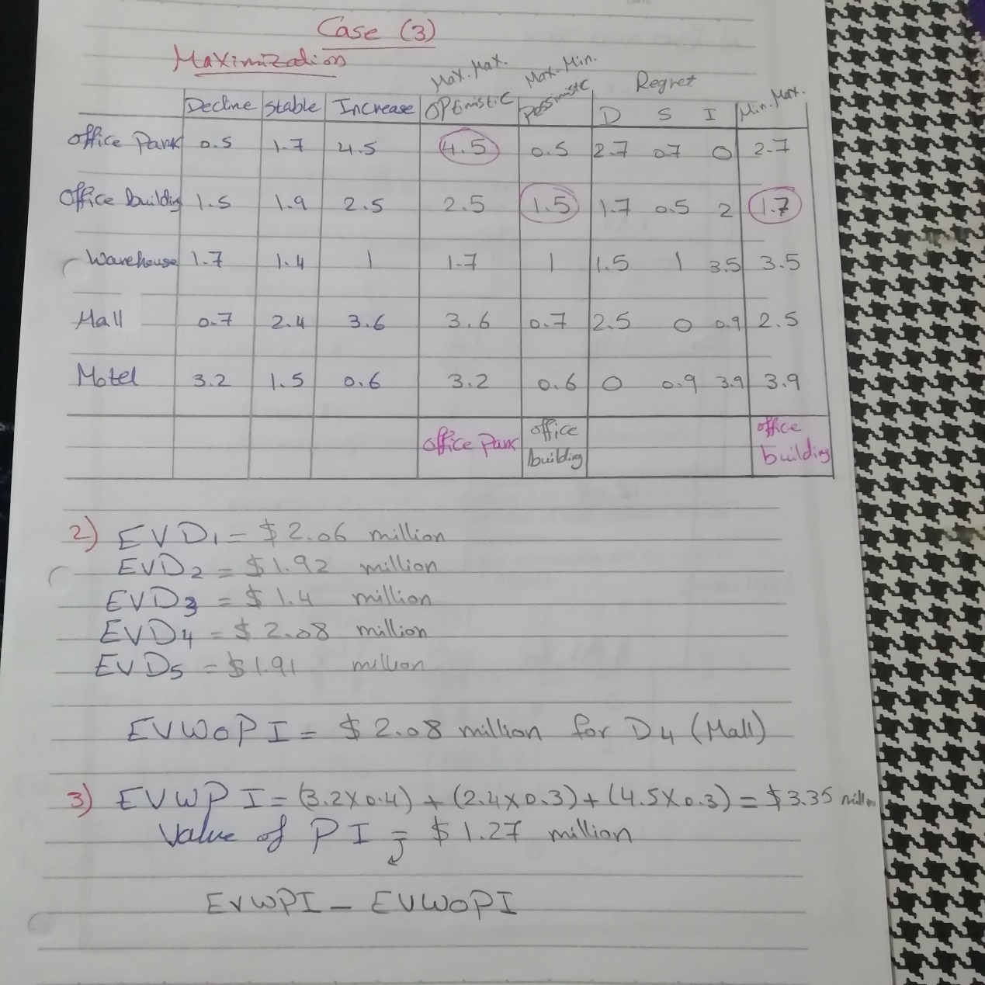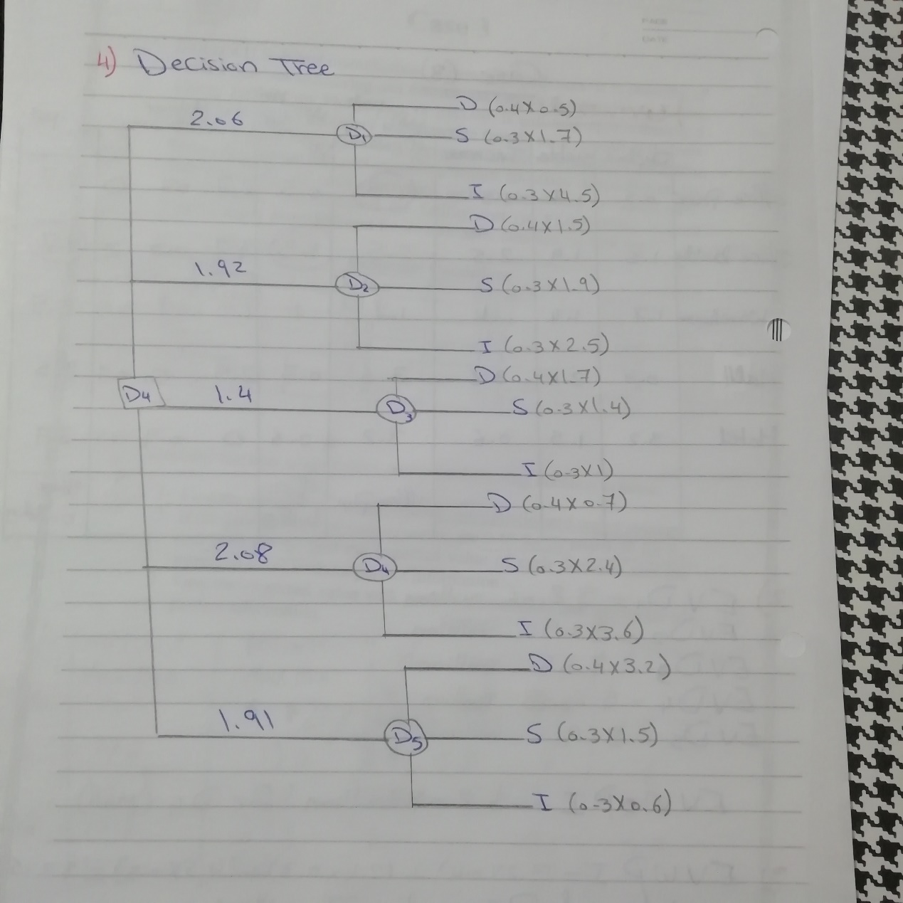

**Case 3**

Microcomp is a U.S.-based manufacturer of personal computers. It is planning to build a new manufacturing and distribution facility in either South Korea, China, Taiwan, the Philippines, or Mexico. It will take approximately 5 years to build the necessary infrastructure (roads, etc.), construct the new facility, and put it into operation. The eventual cost of the facility will differ between countries and will even vary within countries depending on the financial, labor, and political climate, including monetary exchange rates. The company has estimated the facility cost (in $1,000,000s) in each country under three different future economic climates, as follows:

|  |  |  |  |
| --- | --- | --- | --- |
| **Economic Conditions** | | | |
| **Country** | Decline | Stable | Increase |
| South Korea | $21.7 | $19.1 | $15.5 |
| China | 19.0 | 18.5 | 17.6 |
| Taiwan | 19.2 | 17.1 | 14.9 |
| Philippines | 22.5 | 16.8 | 13.8 |
| Mexico | 25.0 | 21.2 | 12.5 |

Determine the best crop to plant, using the following decision criteria:

1. Find the decision of each optimistic, pessimistic, and regret strategy.
2. If the probabilities of state of nature are 0.40 for S1 and 0.30 for S2, and 0.30 for S3. find the expected value of each decision and the expected value without perfect information.
3. Find the expected value with perfect information and the value of perfect information.

